

**HUSACCT**

**Architecture Notebook**

***Eclipse Plugin***

Team 1:

Erik Verhoef 1572690  
René van Aerle 1556647  
Tim Linschoten 1548807  
Niels Nijveldt 1562854  
Stefan Collette 1575795

Teachers: Leo Pruijt, Christian Köppe, Michiel Borkent.

Date: 25-05-2012

Inhoudsopgave

Architectural significant requirements 2

Use cases 2

Use case model 2

Use case Create Workspace 3

Use case Save Workspace 4

Use case Open Workspace 5

Use case Close Workspace 6

Use case Define Architecture 7

Use case Show Logical Architecture 8

Use case Import Architecture 9

Use case Export Architecture 10

Use case Analyse Project 11

Use case Show Analyse frame 12

Use case Show Analysed Architecture Graphics 13

Use case Validate architecture 14

Use case View violation 15

Functional Requirements 16

Non-functional requirements 16

Decisions and justification 17

Physical models 18

Physical class diagram 18

Physical software partitioning model 19

Classmodel in TopCased 20

# Architectural significant requirements

## Use cases

* Create Workspace
* Save Workspace
* Open Workspace
* Close Workspace
* Define Architecture
* Import Architecture
* Export Architecture
* Analyse Source
* Show Analyse Frame
* Show Logical Architecture
* Show Analysed Architecture Graphics
* Validate architecture
* View violation

### Use case model

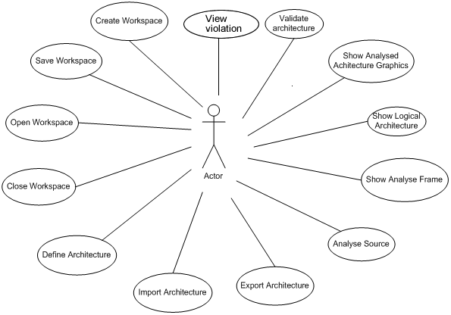

### Use case Create Workspace

**Use case description**

|  |  |
| --- | --- |
| Use Case |  |
| Version: | 1.0 |
| Priority | Must have |
| Use Case | Create Workspace |
| Actors | User |
| Summary | Eclipse is opened with a java project with classes |
| Precondition | The HUSSAC-tool is opened |
| Main scenario | |  |  | | --- | --- | | **Actor actions** | **System actions** | | 1. Actor analyses a project within eclipse |  | |  |  | |  | 1. System creates new workspace with the eclipse project information. | |
| Postcondition | A new workspace is created within the memory. |

### Use case Save Workspace

**Use case description**

|  |  |
| --- | --- |
| Use Case |  |
| Version: | 1.0 |
| Priority | Must have |
| Use Case | Save Workspace |
| Actors | User |
| Summary | The actor wants to save the workspace which is opened. |
| Precondition | There is a analysed project in eclipse. |
| Main scenario | |  |  | | --- | --- | | **Actor actions** | **System actions** | | 1. Actor pushes the button “Save project” when right-clicking on a project |  | |  | 1. System saves the workspace. | |  | 1. A hussact.hu file is created | |
| Postcondition | The workspace is saved and a hussact.hu is added to the root of the project. |

### Use case Open Workspace

**Use case description**

|  |  |
| --- | --- |
| Use Case |  |
| Version: | 1.0 |
| Priority | Must have |
| Use Case | Open Workspace |
| Actors | User |
| Summary | The actor wants to open an earlier saved workspace. |
| Precondition | Eclipse is open with an earlier analysed project in it. |
| Main scenario | |  |  | | --- | --- | | **Actor actions** | **System actions** | | 1. Actor pushes the button “analyse project” |  | |  | 1. System checks if the project has a hussact.hu file in the root | |  | 1. The system loads the workspace with use of the hussact.hu from the root of the project | |  |  | |
| Postcondition | The workspace is opened with the available information loaded. |

### Use case Close Workspace

**Use case description**

|  |  |
| --- | --- |
| Use Case |  |
| Version: | 1.0 |
| Priority | Could have |
| Use Case | Close Workspace |
| Actors | User |
| Summary | This use case is only triggered when the actor analyses a different project. |
| Precondition | There is a project opened. |
| Main scenario | |  |  | | --- | --- | | **Actor actions** | **System actions** | | 1. Actor pushes the button “analyse project” on a different project |  | |  | 1. System checks if a different project is selected 2. System returns a massage with a warning |  1. Actor chooses to continue  |  |  | | --- | --- | |  | 1. System saves workspace 2. System closes current workspace 3. System opens selected workspace. | |
| Postcondition | The current workspace is closed and the new selected workspace is open. |

### Use case Define Architecture

**Use case description**

|  |  |
| --- | --- |
| Use Case |  |
| Version | 1.0 |
| Priority | Must have |
| Use Case | Define Architecture |
| Actors | User |
| Summary |  |
| Precondition | A workspace is opened. |
| Main scenario | |  |  | | --- | --- | | **Actor actions** | **System actions** | | 1. Actor opens the define-view |  | |  | 1. System shows define service gui. | |
| Postcondition | Define architecture GUI is shown. |

### Use case Show Logical Architecture

**Use case description**

|  |  |
| --- | --- |
| Use Case |  |
| Version | 1.0 |
| Priority | Must have |
| Use Case | Show Logical Architecture |
| Actors | User |
| Summary |  |
| Precondition | A logical architecture is defined |
| Main scenario | |  |  | | --- | --- | | **Actor actions** | **System actions** | | 1. Actor opens graphics – defined architecture view |  | |  | 1. System shows logical architecture gui. | |
| Postcondition | Logical architecture GUI is shown. |

### Use case Import Architecture

**Use case description**

|  |  |
| --- | --- |
| Use case |  |
| Version | 1.0 |
| Priority | Must have |
| Use Case | Import architecture |
| Actors | User |
| Summary | If the user has made an architecture in the tool before and exported this with the export architecture use case then the user could import that architecture with this use case |
| Precondition | There is an architecture export file of an existing architecture |
| Main scenario | |  |  | | --- | --- | | **Actor actions** | **System actions** | | 1. Actor pushes ‘Import Architecture’ button in the menu or define view. | 1. System shows pop-up-screen for selecting a file. | | 1. Actor selects the architecture file. 2. Actor pushes “Import” button. | 1. The system triggers the import function of the Hussact | |  |  | |  |  | |
| Postcondition | An existing architecture is loaded. |

### Use case Export Architecture

**Use case description**

|  |  |
| --- | --- |
| Use Case |  |
| Version | 1.0 |
| Priority | Must have |
| Use Case | Export architecture |
| Actors | User |
| Summary | After the architecture is made, the architecture should be able to be exported. |
| Precondition | Architecture rules need to be defined. |
| Main scenario | |  |  | | --- | --- | | **Actor actions** | **System actions** | | 1. Actor pushes ‘export Architecture’ button in the menu after right-clicking on the project or in the define gui. | 1. System shows pop-up-screen for selecting the export path. | | 1. Actor selects the architecture file location. 2. Actor pushes “Export” button. | 1. The system triggers the export function of Husacct | |  |  | |
| Postcondition | The architecture is saved to a .hu file. |

### Use case Analyse Project

**Use case description**

|  |  |
| --- | --- |
| Use Case |  |
| Version: | 1.0 |
| Priority | Must have |
| Use Case | Analyse project |
| Actors | User |
| Summary | The user is able analyse a project, resulting in a graphical representation of the analysis. |
| Precondition | Eclipse is opened with a java project in it. |
| Main scenario | |  |  | | --- | --- | | **Actor actions** | **System actions** | | 1. Actor pushes the “analyse project”- button after right-clicking the project. |  | |  | 1. System analyses the project and triggers open or create workspace. | |
| Postcondition | The project is analysed and can be mapped to the logical architecture. |

### Use case Show Analyse frame

**Use case description**

|  |  |
| --- | --- |
| Use Case |  |
| Version | 1.0 |
| Priority | Must have |
| Use Case | Show analyse |
| Actors | User |
| Summary | Show the analysed application in a tree view and dependency’s. |
| Precondition | An application is analysed. |
| Main scenario | |  |  | | --- | --- | | **Actor actions** | **System actions** | | 1. Actor opens the analyse view. | 1. System shows analyse frame. | |
| Postcondition | Application tree GUI is shown |

### Use case Show Analysed Architecture Graphics

**Use case description**

|  |  |
| --- | --- |
| Use Case |  |
| Version | 1.0 |
| Priority | Must have |
| Use Case | Show Analysed Architecture Graphics |
| Actors | User |
| Summary |  |
| Precondition | A logical architecture is defined |
| Main scenario | |  |  | | --- | --- | | **Actor actions** | **System actions** | | 1. Actor opens the graphics – analysed architecture view. | 1. System shows the analyzed architecture | |
| Postcondition | The analysed architecture is shown on the screen |

### Use case Validate architecture

**Use case description**

|  |  |
| --- | --- |
| Use Case |  |
| Version: | 1.0 |
| Priority | Must have |
| Use Case | Validate architecture |
| Actors | User |
| Summary | Checks if dependencies violate the rules |
| Precondition | A logical architecture is made and the source is mapped to it. |
| Main scenario | |  |  | | --- | --- | | **Actor actions** | **System actions** | | 1. Actor pushes ‘validate project’ when right-clicking the project or pushes validate in the validate view. |  | |  |  | |  | 1. System triggers the validate function of Hussact 2. A table will be filled with violationinformation. | |
| Postcondition | In the validate view a table is shown with all the violations within the project. |

### Use case View violation

**Use case description**

|  |  |
| --- | --- |
| Use Case |  |
| Version: | 1.0 |
| Priority | Must have |
| Use Case | View violation |
| Actors | User |
| Summary | Jump in to the source based on a violation. |
| Precondition | A table is created and has at least 1 violation. |
| Main scenario | |  |  | | --- | --- | | **Actor actions** | **System actions** | | 1. Actor selects violation in the violation table. |  | |  |  | |  | 1. System reads the file and linenumber of the violation. 2. Eclipse opens an editor with the right file and on the right linenumber. | |
| Postcondition | An editor is opened with the right file and is selected on the linenumber where the violation is occurred. |

## Functional Requirements

|  |  |  |
| --- | --- | --- |
| **CFR** | **Description** | **Priority** |
| 1 | Use Husacct functionality in eclipse with the use of a plugin. | Must have |
| 2 | Ability to call the define service. This service is responsible to handle several operations which has to do with defining architecture rules. | Must have |
| 3 | Ability to call the analyse service. This service is responsible to handle several operations which has to do with analyzing. | Must have |
| 4 | Ability to call the validate service. This service is responsible to handle several operations which has to do with validating. | Must have |
| 5 | Ability to save workspace. | Must have |
| 6 | Ability to open workspace. | Must have |
| 7 | Ability to create a new workspace. | Must have |
| 8 | Ability to show the architectural graphics. | Must have |

## Non-functional requirements

|  |  |  |
| --- | --- | --- |
| **NFR** | **ISO 9123 attr.** | **Requirement** |
| **1.** | **Functionality** |  |
| 1.1 | Suitability | The functionality’s of the original Husacct has to be re-used. |
| 1.2 | Suitability | The plugin has to add useful functionality’s for the user within eclipse. |
|  | **Reliability** |  |
|  | Maturity | When the original Husacct goes down, eclipse must still be able to be used. |
|  | **Usability** |  |
|  | Understandability | The division in required steps (manual and automated) must be clear to the user of the tool. |
|  | Operability | The plugin must be easy to operate and is a good addition for the user in eclipse. |
|  | **Maintainability** |  |
|  | Analyseability  Testability | Taking over the development of the tool by other development teams must be unproblematic. |
|  | Testability | Tests must test curtain packages to make sure if something changes it works. |
|  | **Portability** |  |
|  | Installability | The plugin must be easy to install. |
|  | Installability | The plugin must provide a complete installation package (no extra downloads needed). |

## Decisions and justification

|  |  |
| --- | --- |
| **Decision** | **Justification** |
| In order to ensure other development teams can easily maintain the source code of the SACC-tool, we make use of GIT combined with GITHUB. | NF4.1 |
| A library which is an export of the original Husacct is used in the plugin | NF 1.1 |
| Eclipse specific functionality’s are used in the plugin. | NF 1.2 |
| A startview is added to help the user with using the plugin in eclipse. | NF 3.1  NF 3.2 |
| A statevew is added to show which steps are made or have to be made. | NF 3.1 |
| A set of unittest are set up to test the control part of the plugin. | NF 4.2 |
| Export can be made of the plugin and there is an installation guide available. | NF 5.1  NF 5.2 |

# Physical models

## Physical class diagram

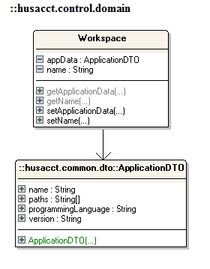

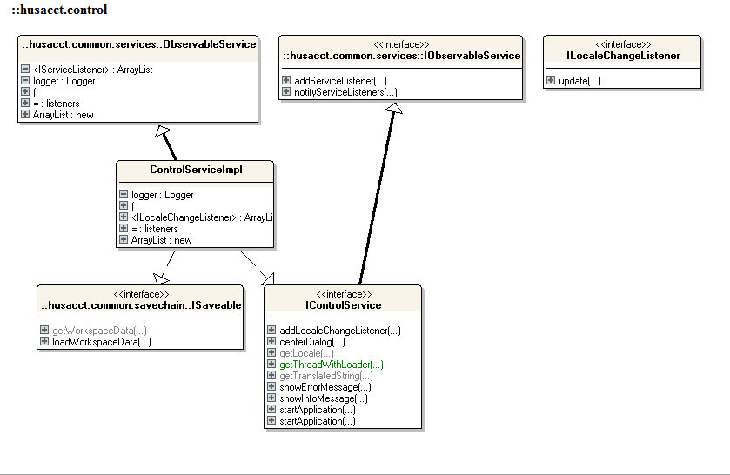

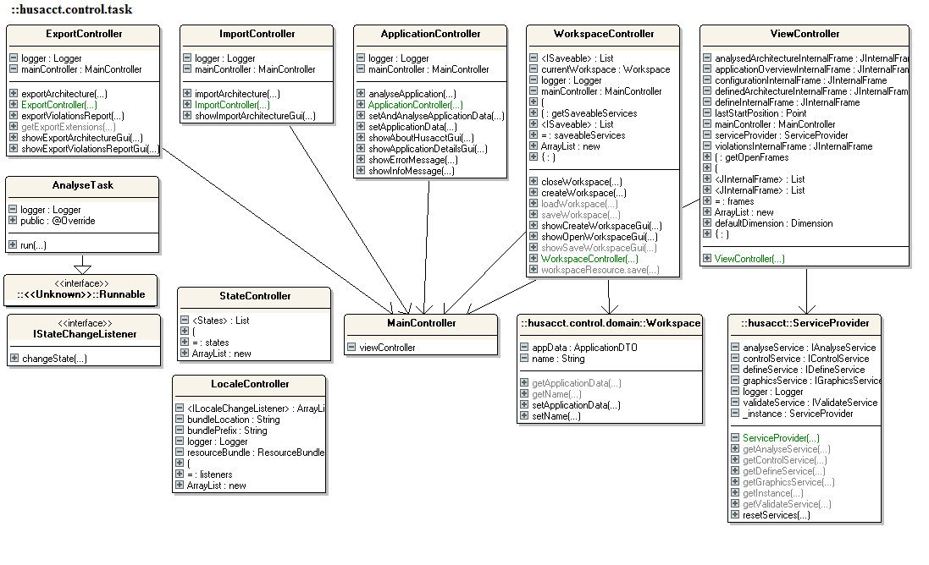

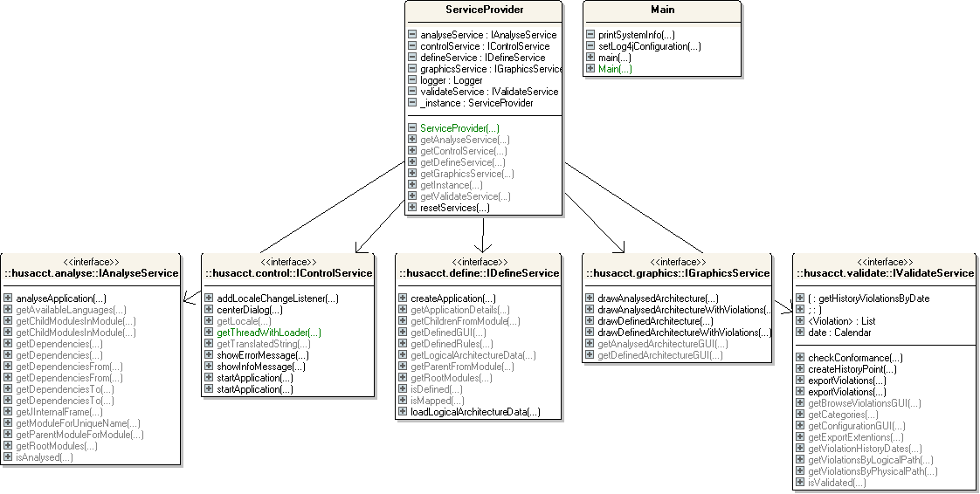

## Physical software partitioning model

